Camtek (CAMT)
Category: Inspection
Est. Price Per Unit: ~$800k - $1M per system

What They Do

Product 101 and Where They Fit into the AI Stack
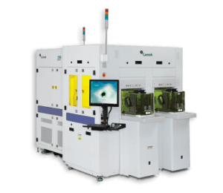Camtek designs and builds optical inspection and metrology systems that sit at the mid-end and back-end of the fab. They inspect wafers after transistors are made but before or during packaging—the quality control checkpoint between chip fabrication and final assembly.
Their Eagle systems do 100% bump inspection for HBM a special on fast optical inspection. Front-end inspection (e.g., from KLA) is more granular but slower, so sampling is used. High Bandwidth Memory stacks 8-12 layers of DRAM vertically, connected by thousands of microscopic through-silicon vias (TSVs) and micro-bumps. If a single bump is defective on layer 4, the entire stack is ruined. Camtek catches these before bonding.
The Hawk system is the newer bet. As the industry moves from micro-bumps to hybrid bonding (copper-to-copper without bumps), you need 3D nanometer-level flatness measurement, not just 2D inspection. Camtek acquired FRT Metrology (German sensor tech) to build this capability.
They're also positioning for glass core substrates (next-gen packaging for Intel/AMD AI chips) and inspect 200+ layer 3D NAND stacks for enterprise SSDs.

Alignment with Overall Thesis
The cost of faulty chips is increasing, so the value and willingness to pay for inspection is increasing.
The shift to chiplets means more connections per package. More connections = more points of failure = more need for inspection. Camtek benefits from complexity, not just volume.
HBM4 (2025/26) increases connection density and may require hybrid bonding, which should drive Hawk upgrades.

Business Model, Customers
Primarily CAPEX-driven hardware sales. ~20-25% recurring from service contracts, spare parts, and software on an installed base of ~3,000 systems.
Camtek is the tool of record at major OSATs (ASE, Amkor) and has secured tool of record status for HBM inspection at tier1 memory makers (implies SK Hynix, Samsung, Micron).
Unlike KLA (which targets front-end fabs), Camtek dominates the assembly houses.
"Double dip" economics: if TSMC keeps packaging in-house, Camtek sells to TSMC. If TSMC hands off to Amkor (as in Arizona), Camtek sells to Amkor.

Comments on Team
Founder led, Israeli (founded 1987).
Co-founder Rafi Amit is CEO and previously CTO.
The FRT acquisition was partly to block competitors from entering via hybrid bonding.

Early View of Moat Hypothesis
KLA and Onto offer higher precision but are slower and more expensive. Camtek's sweet spot is high-speed 100% inspection that doesn't bottleneck the line. In high-volume packaging, speed matters more than atomic-level precision. 3,000+ machines in the field. Displacing Camtek requires retraining operators and rewriting inspection recipes. Switching costs are high for low-margin OSATs.
The FRT acquisition blocked competitors from using hybrid bonding as an entry point.

Why They're Interesting, and Why Now
Pick-and-shovel play on advanced packaging. As transistor scaling slows, performance gains come from stacking chips vertically. Camtek provides the inspection layer. We have to believe packaging complexity keeps growing.
HBM4 cycle (2025/26) should drive Hawk upgrades, though timing is uncertain.
Glass substrates give optionality but are speculative.
As packaging becomes more value-add (e.g., CoWoS), then TSMC and other fabs also need additional inspection, and not just the OSATs. Camtek has deeper relationships with OSATs vs. Fabs (ONTO and KLAC have deeper relationship with Fabs) but it creates volume tailwinds.

Key Risks
CAPEX-driven model is cyclical.
KLA could push deeper into back-end/packaging inspection.
If hybrid bonding adoption is slower than expected, Hawk uptake disappoints.
Customer concentration in HBM memory makers and large OSATs.
Hybrid Bonding and high fidelity optics are not Camtek's original technology (they acquired it). ONTO has the dragonfly system which claims to be able to handle hybrid bonding, and KLA has the capabilities but the machines are slower and more expensive. We would need to assess whether the Hawk machine is good enough to sell to both Fabs and OSATs for the next generation of chips.

Gaps in Understanding / Key Questions
How differentiated is Hawk vs. KLA/Onto for hybrid bonding? Does the speed vs. precision trade-off hold at nanometer scale?
What portion of revenue is truly AI-driven vs. traditional packaging?
Has FRT/SurfaceSens technology been fully productized?

Select Financial Graphs

R1: Total Revenue & YoY Growth
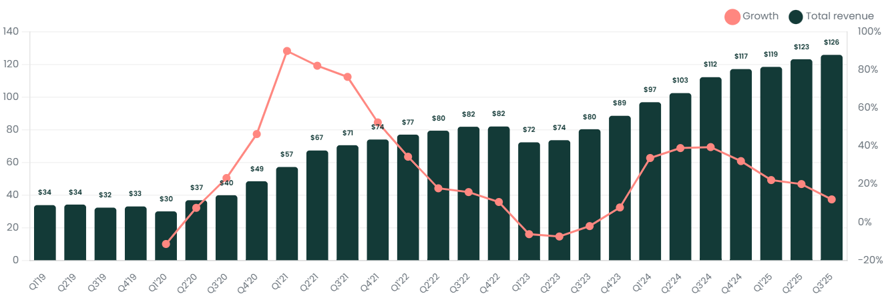

I1: Inventory Turns
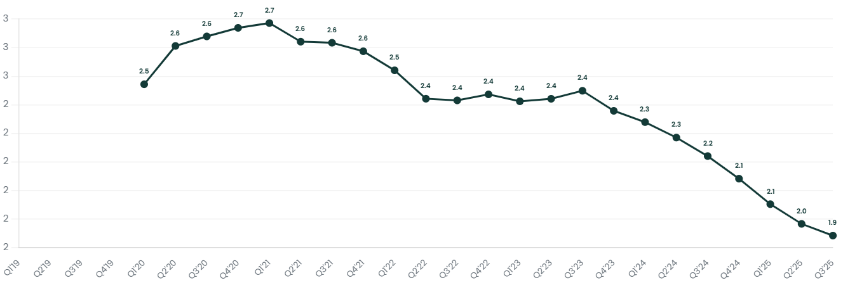

P4: Operating Margin
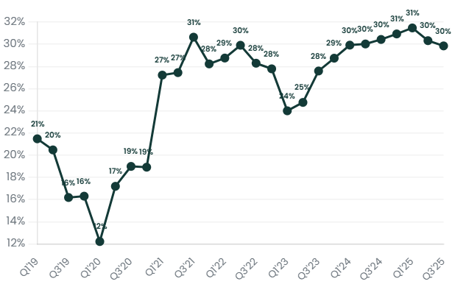

V1: EV/Sales NTM
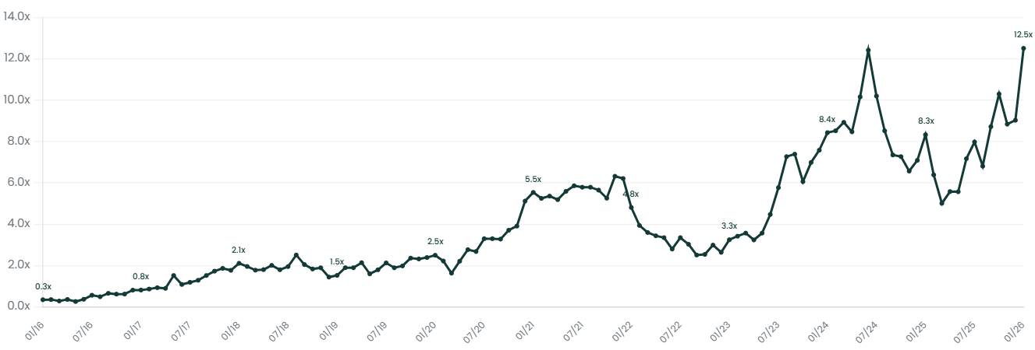

Patent Analysis

Inspection & Metrology: KLA vs CAMT vs ONTO
KLA dominates patent volume across defect inspection, overlay metrology, and CD metrology. Camtek and Onto have minimal patent filings in comparison—consistent with their niche positioning rather than broad R&D.
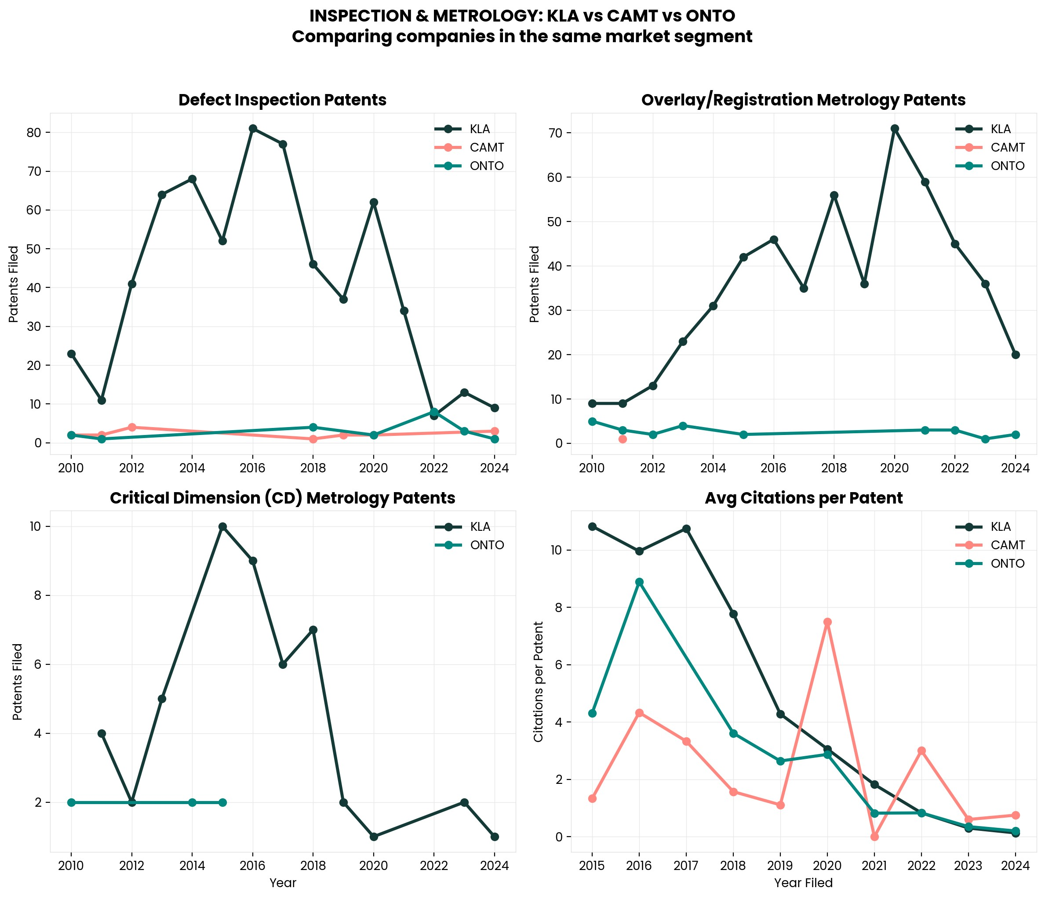

Citation Rate Comparison
Despite lower patent volume, Camtek's citation rate spiked in 2021, suggesting their packaging inspection IP became more relevant as advanced packaging ramped.
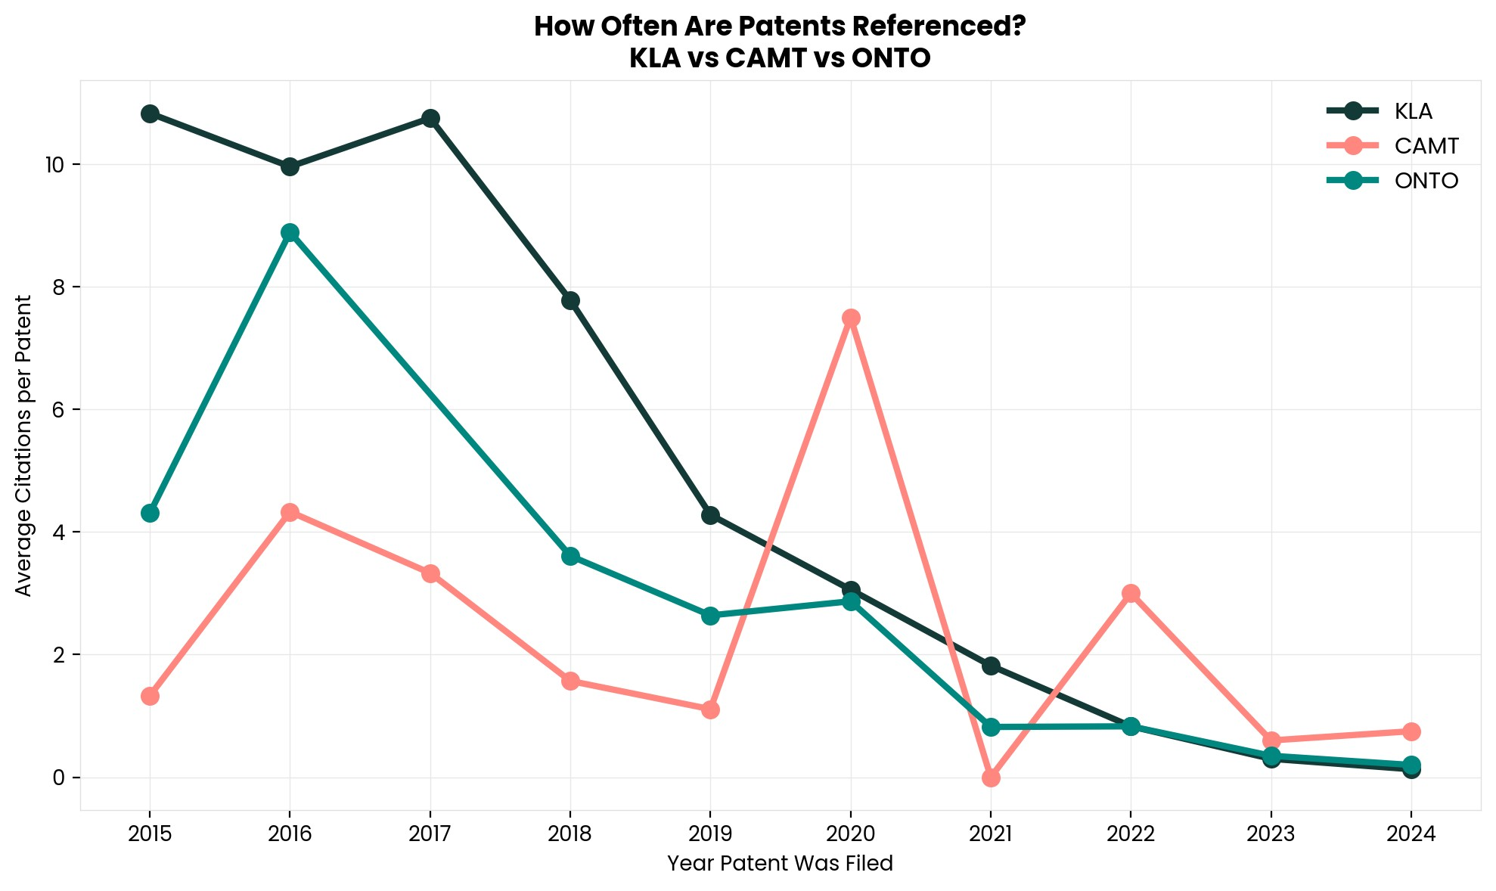

Interesting Topics to Read
Back end semiconductor testing
Camtek vs. ONTO vs. KLA positioning
Hybrid Bonding vs. micro-bump inspection requirements
HBM4 packaging architecture
Glass Core Substrates for AI chips
Through-Silicon Via (TSV) technology

